

Social Media Form filler
Specification document – April 8th 2016

Description
The goal of this project is to create a standalone web application in Asp.net MVC that asks the user which social media account to log in as and then upon logging in to that account, fill in information about that user. Facebook, Twitter and other social media platforms have .NET libraries that can help aid you.

Design
The website should look similar to this:
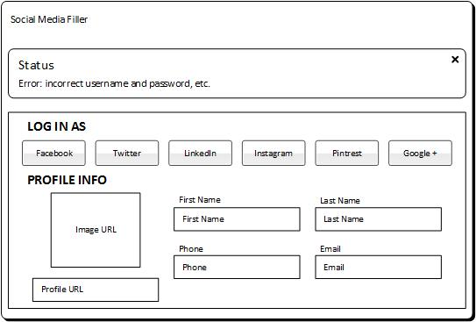

Requirements
- The website can be plain, there is no design to implement, we only want to see the functionality. Use bootstrap form, button and alert elements.
- When a user selects one of the buttons that says Facebook, Twitter, LinkedIn, etc. The website should redirect the user to that services OAuth 2.0 log in screen. The user logs in and upon returning back to this website you may use the social media’s API to fill in information for the fields listed above.
  - First name
  - Last name
  - Phone
  - Email
  - Profile Picture
  - URL
- If the user has null or blank info, it’s okay to leave it blank. We are only trying to glean as much as we can from the user.
- You do not need to add a save button. You do not have to save this to a database.
- Make sure to add a status message at the top this would be bootstraps “.alert” class box.
- If you would like, you may want to add test cases to this.

Deliverables
You are to deliver the code, html, and any other assets to a private git repository here: https://github.com/Jagalee/social-media
Note: It is a private Github account. You will need to share your Github username with us so that we can add you to the repository. Only then can you upload your code there.

